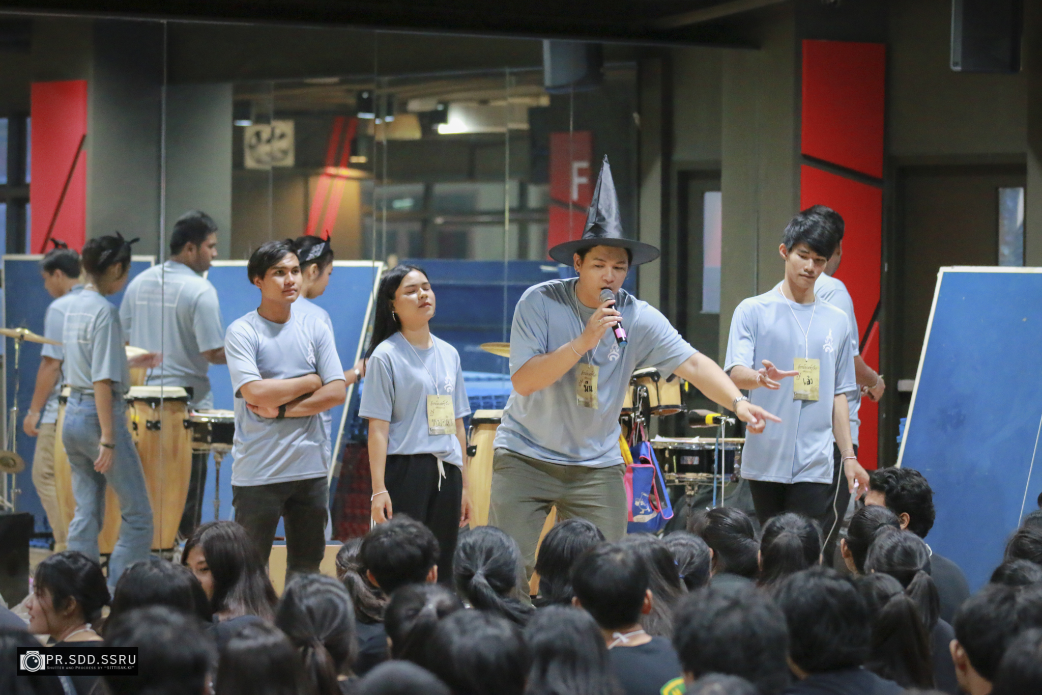
สวนสุนันทา เปิดบ้านรับน้องใหม่รหัส 62

Welcome Week for SSRU New Student 2019
The SSRU Welcome Week includes many important and fun events and activities dedicated to helping all new students prepare and be ready to start their academic study. This is the opportunity for SSRU to welcome “ Look Pra Nang” new environment and to the people who will help shape their experiences at University. We really cannot wait to meet you and introduce you to your new community! This essential time before classes start allows the new students to get to know our campuses, meet fellow students and academics, get a sense of the University life that awaits them.

All areas of the University are excited to meet them and together, Student Development Division Team and Student Organization members have put together an exciting program of free events and activities that will provide our new students with essential information to get started, opportunities to network, explore and contribute, and provide them with that first and lasting connection to the University. We extend our thanks to staff, faculty and volunteer students who made the Orientation Week as successful as it was.

