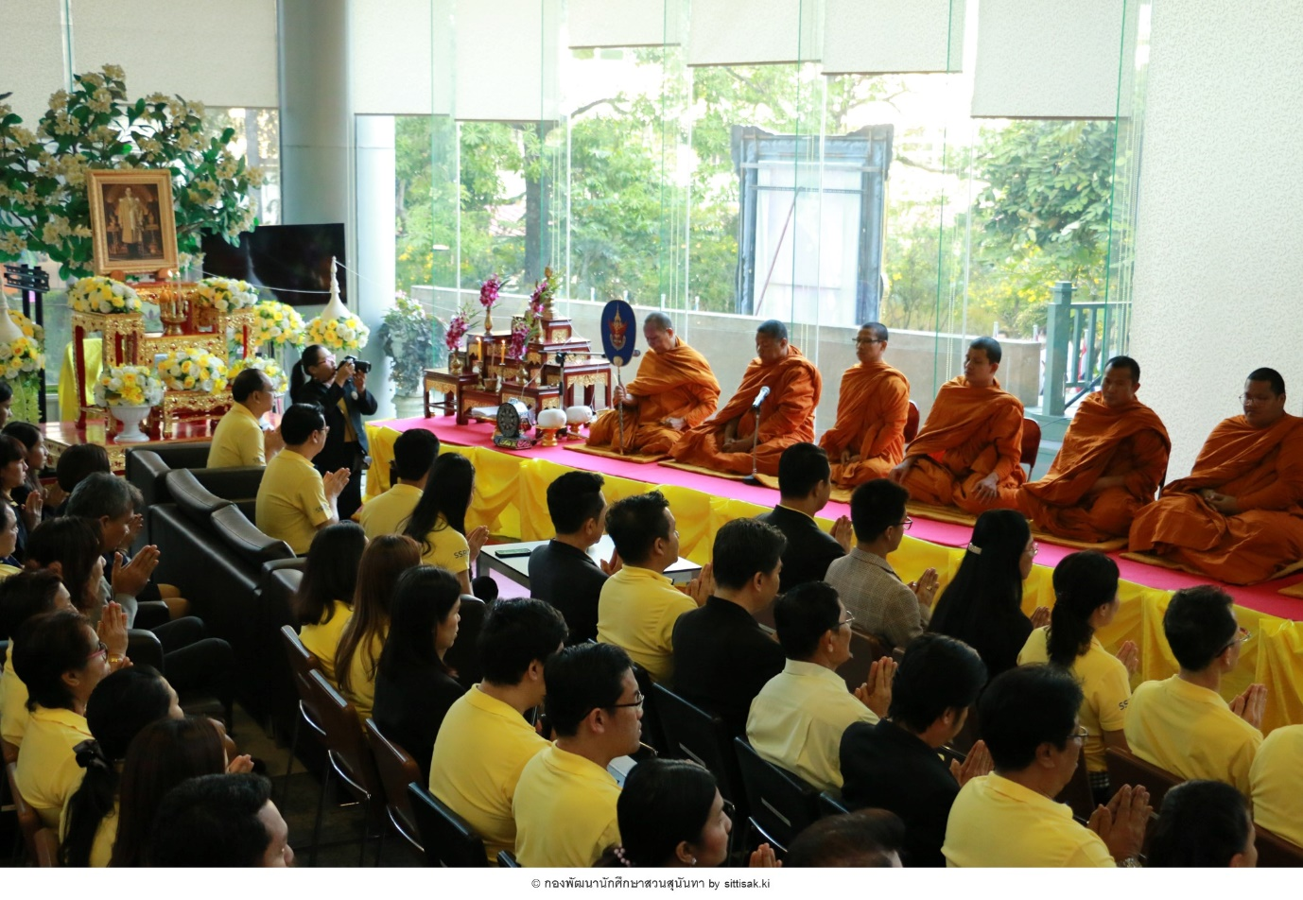
พิธีทำบุญเนื่องในวันคล้ายวันพระราชสมภพพระบาทสมเด็จพระบรมชนกาธิเบศ — ที่ มหาวิทยาลัยราชภัฏสวนสุนันทา
Holding activities commemorating the life and reign of the beloved monarch, SSRU Student Organization and Student Development Division co-organized the ceremony to pay homage and merit making ceremony for His Majesty King Bhumibol Adulyadej the Great to mark His Majesty’s birthday anniversary on December 4, 2019. At this event, Associate Professor Dr. Luedech Girdwichai, President of SSRU, led executives, staff members and students participated in an alm-offering to 9 Buddhist monks and paid respect to show loyalty and gratitude to the late King Bhumibol Adulyade at the foyer, Office of the President.

